CIS31041 - Practical for Data Mining

Reg. No :SEU/IS/20/ICT/084 Lab Sheet 03

Title: Python for Data Mining
Aim:
- Work with Google Colab
Task:
- Getting practices with python
- Getting practices of colab
Exercises
- Basic mathematical operations using python
  - Addition
  - Subtraction
  - Multiplication
  - Division
  - Floor Division
  - Power

# Define two numbers
a = 15
b = 4

# i. Addition
addition = a + b
print("Addition:", addition)

# ii. Subtraction
subtraction = a - b
print("Subtraction:", subtraction)

# iii. Multiplication
multiplication = a * b
print("Multiplication:", multiplication)

# iv. Division
division = a / b
print("Division:", division)

# v. Floor Division
floor_division = a // b
print("Floor Division:", floor_division)

# vi. Power
power = a ** b
print("Power:", power)
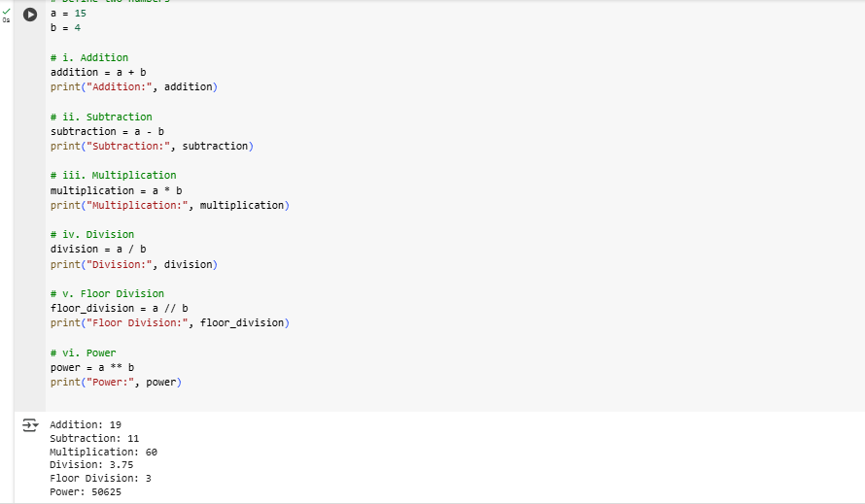

- Working of String array
  - Print the string array
  - Multiply the string array
  - Retrieve a character
  - Retrieve the set of character
  - Concatenate the string
  - Find the length of the string array

# Define a string array
string_array = ["Hello", "World", "Python"]

# i. Print the string array
print("String Array:", string_array)

# ii. Multiply the string array (repeat each string 2 times)
multiplied_array = [s * 2 for s in string_array]
print("Multiplied String Array:", multiplied_array)

# iii. Retrieve a character (e.g., first character of first string)
char = string_array[0][0]
print("First character of first string:", char)

# iv. Retrieve a set of characters (e.g., first 3 characters of second string)
subset = string_array[1][0:3]
print("First 3 characters of second string:", subset)

# v. Concatenate the string array into one string
concatenated_string = " ".join(string_array)
print("Concatenated String:", concatenated_string)

# vi. Find the length of the string array (number of elements)
array_length = len(string_array)
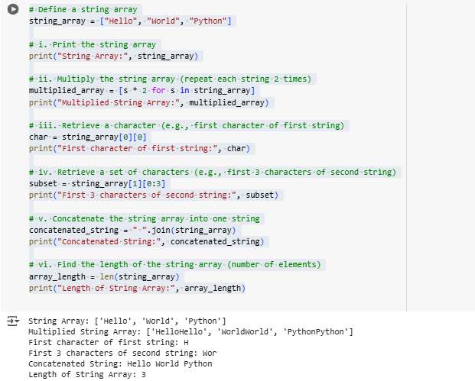
print("Length of String Array:", array_length)

- List
  - Introduction to list
  - Assigning value for index
  - Assigning multiple values
  - Length of list
  - Append the element
  - Remove the element
  - Copy the list

# i. Introduction to list
my_list = [10, 20, 30, 40]
print("Initial List:", my_list)

# ii. Assigning value for index (change value at index 2)
my_list[2] = 35
print("After assigning value at index 2:", my_list)

# iii. Assigning multiple values (replacing a slice)
my_list[1:3] = [25, 45]
print("After assigning multiple values:", my_list)

# iv. Length of list
length = len(my_list)
print("Length of the list:", length)

# v. Append the element
my_list.append(50)
print("After appending 50:", my_list)

# vi. Remove the element
my_list.remove(25)
print("After removing 25:", my_list)

# vii. Copy the list
copied_list = my_list.copy()
print("Copied List:", copied_list)

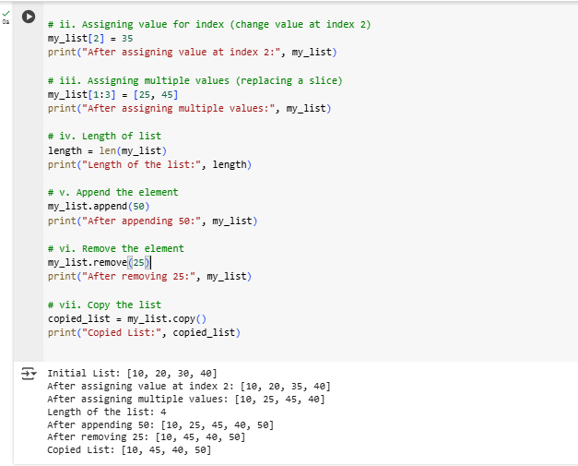

- Control flow structure
  - If -elif-else
  - While
  - For
  - Continue
  - Break

# i. if - elif - else
num = 15
if num > 20:
print("Number is greater than 20")
elif num == 20:
print("Number is equal to 20")
else:
print("Number is less than 20")

# ii. while loop
print("\nWhile Loop:")
count = 0
while count < 3:
print("Count is:", count)
count += 1

# iii. for loop
print("\nFor Loop:")
for i in range(5):
print("i =", i)

# iv. continue
print("\nContinue Statement:")
for i in range(5):
if i == 2:
continue # Skip the iteration when i == 2
print("i =", i)

# v. break
print("\nBreak Statement:")
for i in range(5):
if i == 3:
break # Exit the loop when i == 3
print("i =", i)
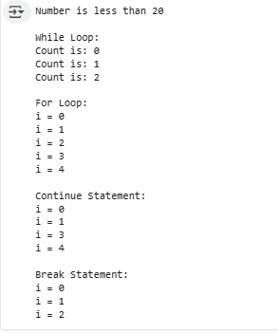

- Basic Function in python

# Function without parameters
def greet():
print("Hello! Welcome to Python.")

# Function with parameters
def add(a, b):
return a + b

# Function with default parameter
def welcome(name="Guest"):
print(f"Welcome, {name}!")

# Function with return statement
def square(x):
return x * x

# Calling the functions
greet() # No parameters
result = add(10, 5) # With parameters
print("Addition Result:", result)

welcome("Alice") # With argument
welcome() # Using default

squared = square(6) # Using return value
print("Square of 6 is:", squared)

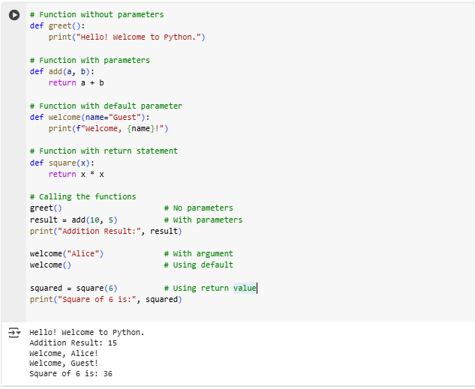

- Stack (Last In First Out (LIFO))
  - Create the stack
  - Append the stack
  - Remove the element in stack

# i. Create the stack
stack = []
print("Initial Stack:", stack)

# ii. Append to the stack (push operation)
stack.append(10)
stack.append(20)
stack.append(30)
print("Stack after pushing elements:", stack)

# iii. Remove the element from the stack (pop operation)
removed_element = stack.pop()
print("Removed Element:", removed_element)
print("Stack after popping element:", stack)

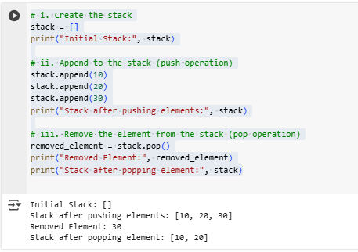

- Queue (First In First Out ( FIFO))

  - Create the queue
  - Insert the element in queue
  - Remove the element in queue

from collections import deque

# i. Create the queue
queue = deque()
print("Initial Queue:", queue)

# ii. Insert the element in queue (enqueue)
queue.append("A")
queue.append("B")
queue.append("C")
print("Queue after enqueuing elements:", queue)

# iii. Remove the element in queue (dequeue)
removed_element = queue.popleft()
print("Removed Element:", removed_element)
print("Queue after dequeuing element:", queue)

